**Article 8. Manufacturing & Logistics Zoning Districts: ML-1, ML-2**

**8.1 PURPOSE**

**8.2 USES**

**8.3 DIMENSIONAL AND DESIGN STANDARDS**

**8.4 SUPPLEMENTAL DEVELOPMENT STANDARDS**

**8.1 PURPOSE**

**A. ML-1 Manufacturing and Logistics Zoning District**

The ML-1 Manufacturing and Logistics Zoning District is intended to accommodate a range of warehouse/distribution and light industrial uses, including a variety of light manufacturing and assembly. The ML-1 Zoning District includes significant screening and buffering requirements to ensure adequate separation and mitigation of potential impacts on surrounding areas. Limited restaurant, retail, and personal service uses to accommodate area workers are also allowed in the zoning district. The ML-1 Zoning District is generally located in areas readily accessible by arterials and interstates, as well as freight rail.

**B. ML-2 Manufacturing and Logistics Zoning District**

The ML-2 Manufacturing and Logistics Zoning District is intended to accommodate industrial uses, including those uses that may be hazardous or noxious. Such uses may have significant external impacts and may include large areas of outdoor storage or operation. The ML-2 Zoning District includes significant screening and buffering requirements to ensure adequate separation and mitigation of potential impacts on surrounding areas. The ML-2 Zoning District is generally located in areas readily accessible by arterials and interstates, as well as freight rail.

**8.2 USES**

Article 15 lists permitted, temporary, and accessory uses for the Manufacturing and Logistics Zoning Districts. Use definitions are found in Article 15. Prescribed conditions applicable to certain principal uses, temporary uses, and accessory uses are also found in Article 15.

**8.3 DIMENSIONAL AND DESIGN STANDARDS**

**A. General**

**1.** The tables below include the dimensional and design standards for the Manufacturing and Logistics Zoning Districts. Standards within the tables below may contain specific regulations organized by frontage type (Section 3.5).

**2.** Where this Ordinance refers to frontages in general, transit station, off-street public path, public park shall not be considered a frontage within the Manufacturing and Logistics Zoning Districts.

**3.** In the tables below, where a cell contains a standard or a “✓” the standard is applicable. Where a cell is blank and shaded, the standard does not apply.

**B. Lot**

Lot standards govern the basic dimensions of lots, including but not limited to minimum area, width, and coverage as applicable. These standards are intended to provide a rational basis for the division, organization, and development of land within the City of Charlotte.

| **Table 8-1: Manufacturing and Logistics Zoning Districts Lot Standards1** | | | |
| --- | --- | --- | --- |
|  | | **ML-1** | **ML-2** |
| **A** | **Minimum Lot Width** (feet) | 50 | 50 |
| **1** | Lot Standards do not apply to individual sublots but do apply to the parcel on which the sublot(s) is located. | | |

**C. Building Siting**

Building siting standards govern the placement of buildings on lots and are intended to ensure that development maintains compatibility with its surrounding context and the intent of the applicable zoning district.

| **Table 8-2: Manufacturing and Logistics Zoning Districts Building Siting Standards** | | | |
| --- | --- | --- | --- |
|  | | **ML-1** | **ML-2** |
| **A** | **Frontage Setback Line** (from future back of curb)(feet) **1, 2** | | |
|  | Uptown Signature |  |  |
| Main Street |  |  |
| Linear Park |  |  |
| 4-5 Lane Avenue/Boulevard | 36 | 36 |
| 6 or more Lane Avenue/Boulevard | 40 | 40 |
| 2-3 Lane Avenue | 36 | 36 |
| Transit Station, Off-Street Public Path, Public Park **3** | 20 | 20 |
| Uptown Primary | 20 | 20 |
| Primary – Other | 36 | 36 |
| Uptown Secondary | 16 | 16 |
| Secondary | 36 | 36 |
| Parkway (Measured from ROW) | 20 | 20 |
| Limited Access (Measured from ROW) | 20 | 20 |
| **B** | **Minimum Side Setback** (feet) | 0 | 0 |
| **C** | **Minimum Rear Setback** (feet) **4** | 10 | 10 |

|  |  |
| --- | --- |
| **1** | On local and collector streets, measured from the curb location for Industrial Local Street Cross Section in CLDSM or the existing back of curb, whichever is farthest from the centerline. If SSI standards require the relocation of the back of curb or the back of curb is voluntarily relocated, that shall be considered the existing back of curb location. |
| **2** | In no case shall any building entry be located closer than six feet to an existing or proposed off-street public path or shared use path. |
| **3** | For the Transit Station/ Off-Street Public Path, Public Park frontage, shall be measured from a property line or right-of-way line. If there is an easement in place for any frontage, then the measurement shall be taken from such easement. For any frontage abutting a reservation for a future frontage, the frontage setback line shall be measured from the edge of the reservation area. |
| **4** | Rear setbacks are not required for industrial uses when the rear setback is adjacent to railroad rights-of-way for freight rail. |

**D. Building Height**

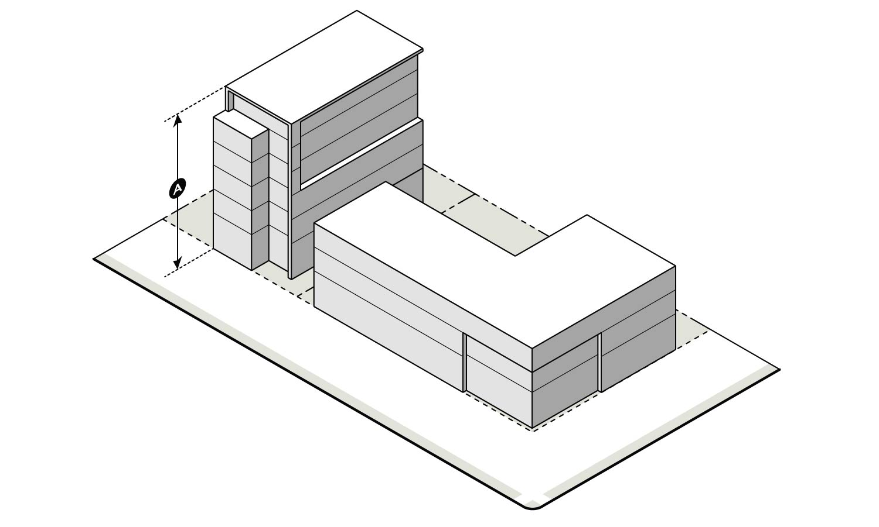Building height standards govern the maximum heights of buildings as applicable and are intended to provide flexibility while maintaining appropriate transitions to adjacent areas.

| **Table 8-3: Manufacturing and Logistics Zoning Districts Building Height Standards** | | | |
| --- | --- | --- | --- |
|  | | **ML-1** | **ML-2** |
| **A** | **Maximum Building Height** (feet) **1, 2** | 80 | 80 |

|  |  |
| --- | --- |
| 1 | The height and location of structures may be restricted by the limitations set forth in the Code of Federal Regulations (CFR) Title 14 Part 77: Safe, Efficient Use, and Preservation of the Navigable Airspace.  A notice of proposed construction FAA Form 7460-1 must be filed with the FAA for construction or alteration that impacts any of the imaginary surfaces as defined in 14 CFR Part 77 or is more than 200 feet in height above the ground at its site at least 45 days prior to construction. The Aviation Department Planning Division may serve as a point of contact for information regarding building notification requirements and obstruction evaluation |
| 2 | The maximum building height of any structure within 200 feet from the lot line of residential uses or vacant land in a Neighborhood 1 Place Type is limited as follows: Portions of a structure within the first 100 feet are limited to a maximum height of 50 feet. Portions of a structure located between 100 and 200 feet are limited to a maximum height of 65 feet. Beyond 200 feet, the building height is limited by the maximum height of the zoning district. Building heights for all portions of a structure shall be measured from the average grade established for the whole building. This limitation does not apply to public parks of three acres or greater within a Neighborhood 1 Place Type, nor to an area of two or fewer parcels totaling no more than three acres within a Neighborhood 1 Place Type. |

**E. Building Design Standards**

Design standards govern the fundamental elements of building design and are intended to encourage the creation of a built environment that is aesthetically and functionally of a high-quality.

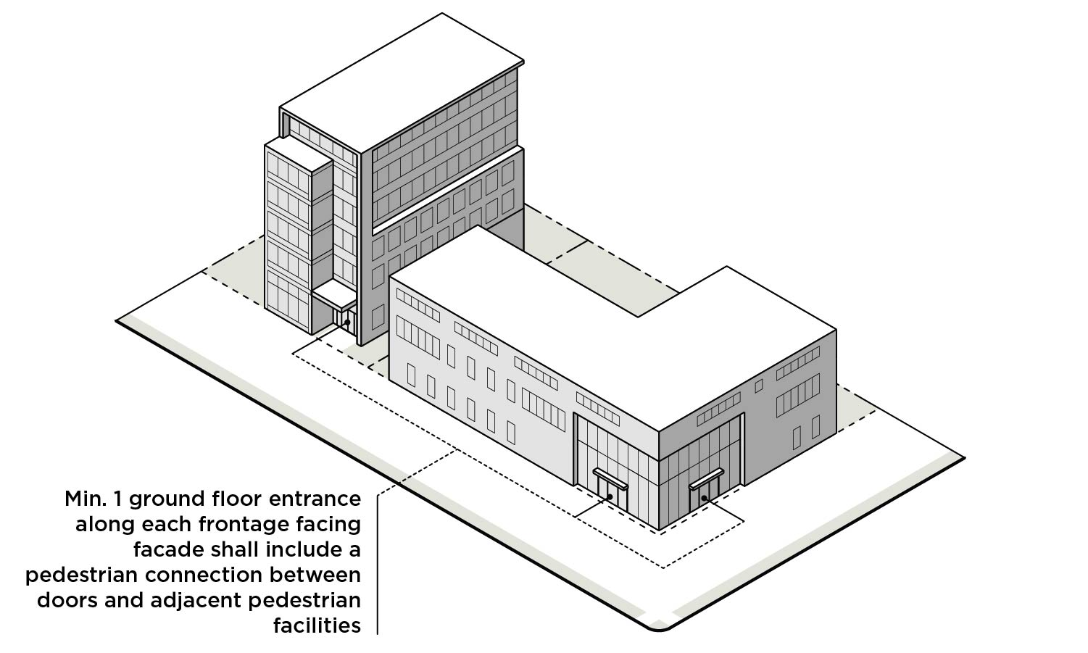

| **Table 8-4: Manufacturing and Logistics Zoning Districts Building Design Standards** | | | |
| --- | --- | --- | --- |
|  | **ML-1** | **ML-2** | |
| **Ground Floor and Entrance Design** | | | |
| A minimum of one ground floor entrance along each frontage facing facade except for Limited Access frontage shall include a pedestrian connection between doors and adjacent pedestrian facilities, where such facilities are present or are required by this Ordinance. **1** | | | |
| Main Street |  | |  |
| 4-5 Lane Avenue/Boulevard | ✓ | | ✓ |
| 6 or more Lane Avenue/Boulevard | ✓ | | ✓ |
| 2-3 Lane Avenue | ✓ | | ✓ |
| Transit Station, Off-Street Public Path, Public Park |  | |  |
| Primary – Other | ✓ | | ✓ |
| Secondary | ✓ | | ✓ |
| Parkway | ✓ | | ✓ |
| Limited Access (Measured from ROW) |  | |  |

|  |  |
| --- | --- |
| **1** | The Zoning Administrator may waive this requirement if they determine that the nature of the use does not require such pedestrian connections, for example warehouse and distribution centers, airports, truck and rail freight terminals, and other similar uses. |

**F.** **Building Materials**

The following building materials are limited to 50% of each façade along a frontage. They may also be used as a component of construction when not a surface finish material without limitation.

**1.** Corrugated metal siding; however, the reuse of pre-fabricated shipping containers is permitted and is not subject to this limitation, subject to compliance with the building code and other applicable codes

**2.** Plain concrete masonry units (CMU)

**3.** Plastic

**4.** T-111 composite plywood siding

**5.** Vinyl

**8.4 SUPPLEMENTAL DEVELOPMENT STANDARDS**

**A.** **General Development Standards**General development standards are found in Article 16.

**B. Accessory Structures**

Standards for accessory structures are found in Article 17.

**C. Architectural Features**

Standards for architectural features are found in Article 18.

**D. Off-Street Parking**

Standards for off-street parking and bicycle parking are found in Article 19.

**E. Landscaping and Screening**

Landscaping and screening standards are found in Article 20.

**F. Loading and Service**

Standards for loading spaces and service areas are found in Article 21.

**G. Signs**

Standards for signs are found in Article 22.

**H. Drainage**

Standards for drainage are found in Article 24.